CS6360.004 Fall 2019

Submitted by - Kapil Gautam (KXG180032)

Assignment 2 Solutions – Install a Database

Using SQL Server Management Studio

1. Connectivity to Company database and list of tables created :

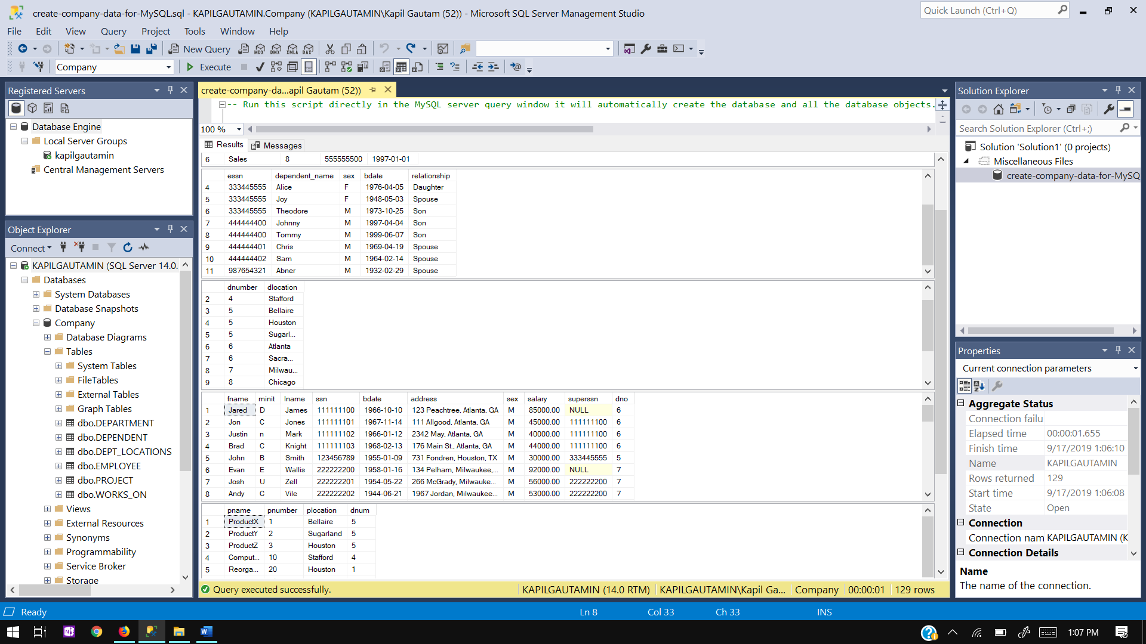

2.Query screen shots along with the results :

a.) Insert your name into the Company database employee table with social security number of 111111111 and department 6. You don’t need to use your real address.

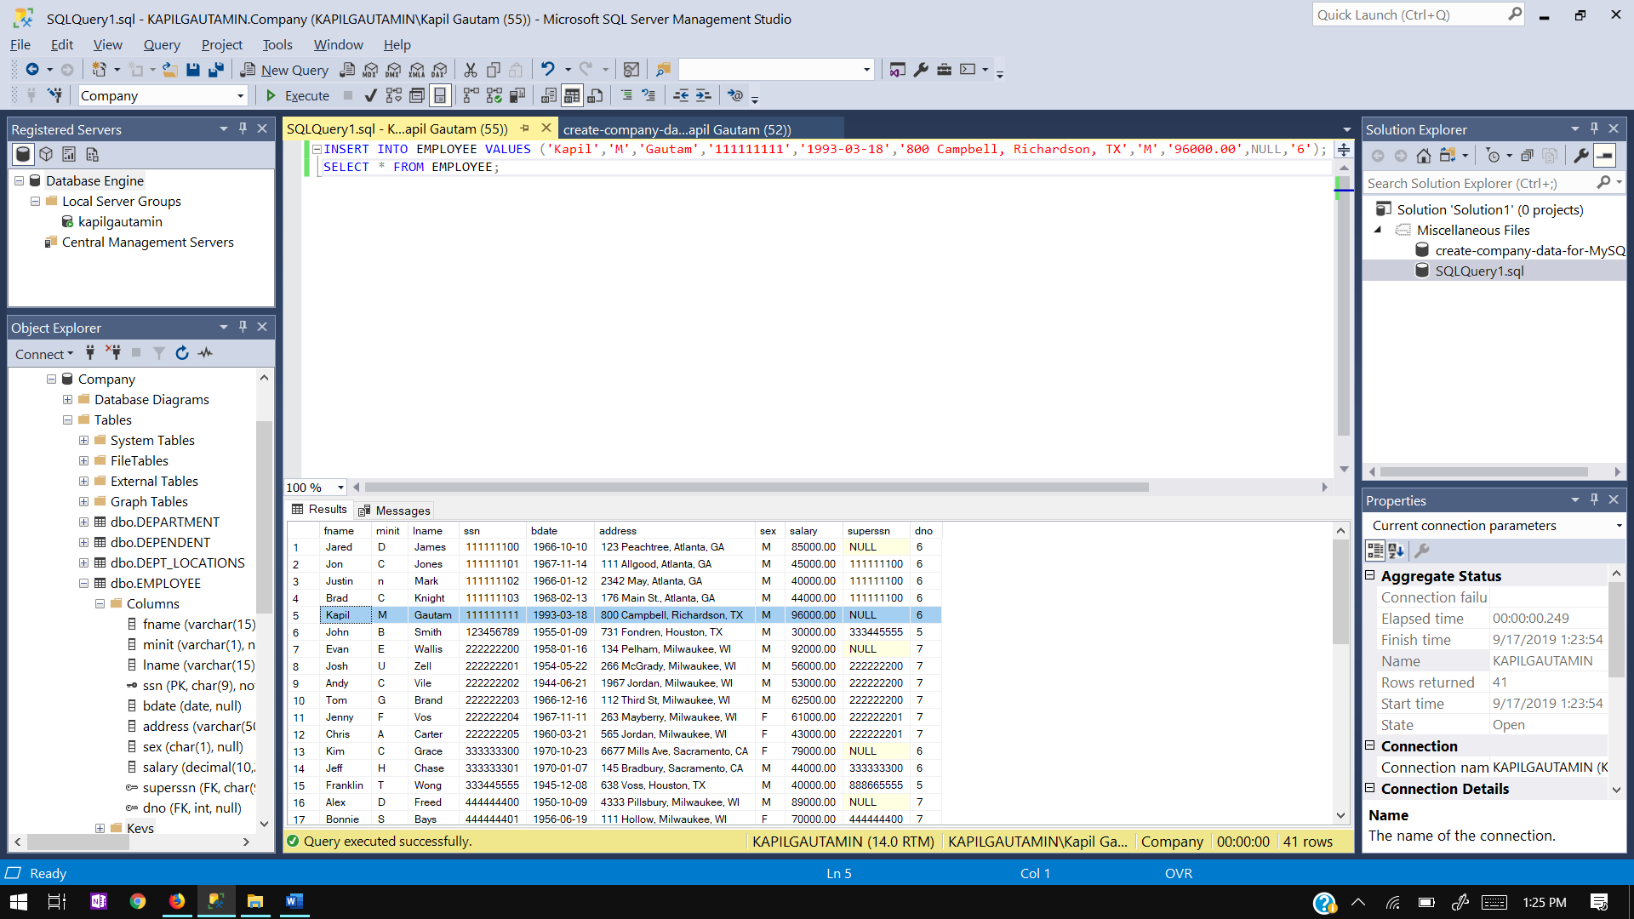

b.) Update your employee record to show 111111100 as your supervisor. Query to show your record only.

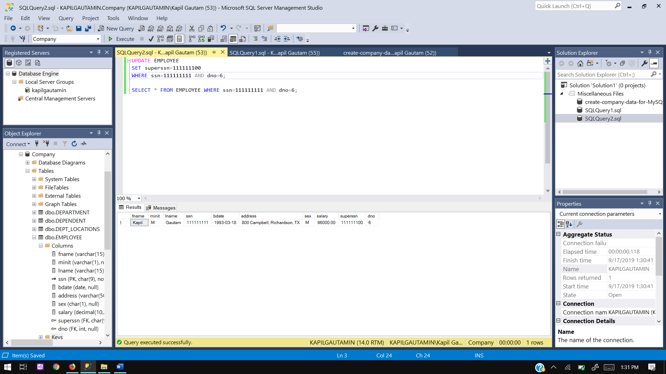

c.) Show all employees who work for supervisor Jared D. James and those who work for supervisor Evan E. Wallis. That is, everyone who works for either one of those two people. (You can write this so the query doesn’t involve the name, if you wish.)

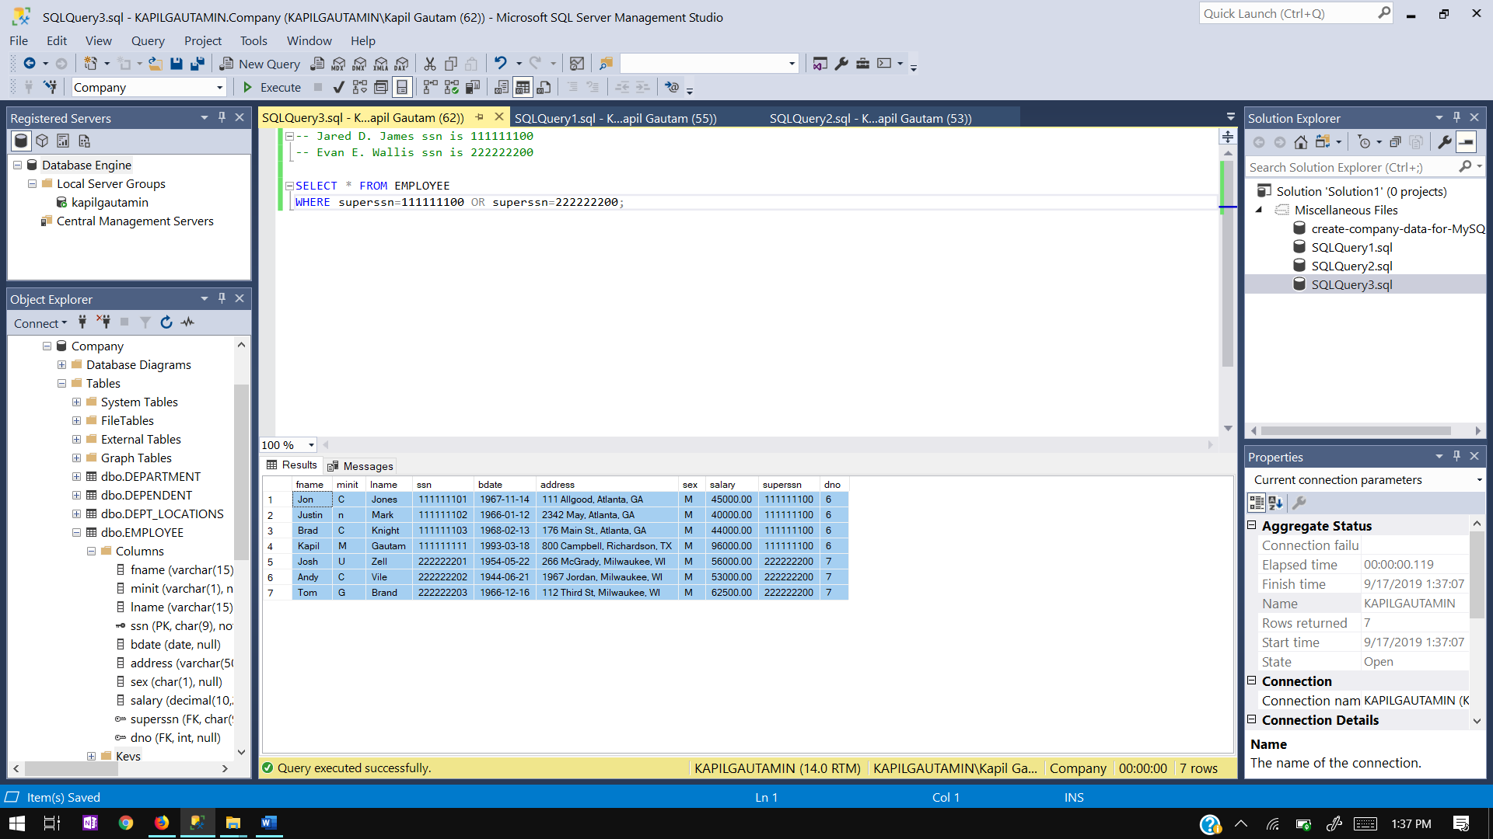

d.) Show all employees who make more than $50,000 per year, who are over 30 years old, and who live in Wisconsin (state abbreviation WI.)

